**Functional Requirement (Epic):** Registration

**User Story Number:** USN-1

**User Story / Task Story:** As a user, I can register for the application by entering my email, password, and confirming my password.

Points: 1

**Priority:** High

**Team Members:** Gnana Dheepika G G

Screenshots:

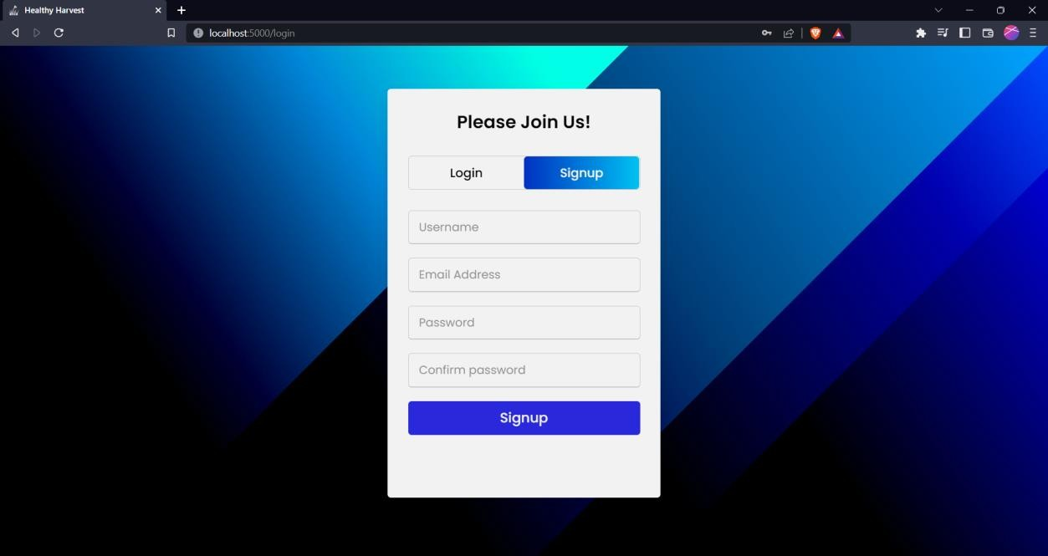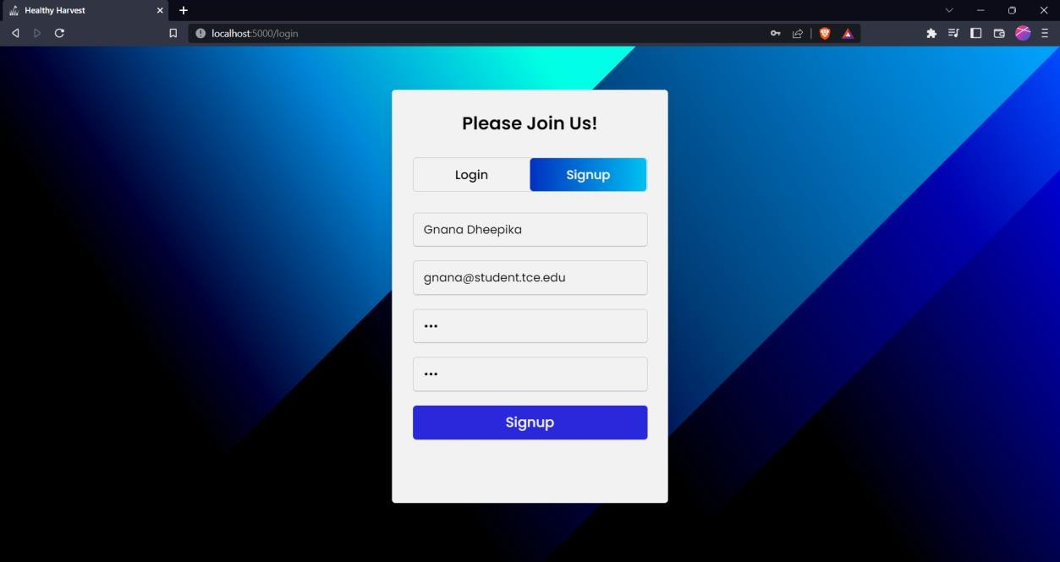

**Functional Requirement (Epic):** Registration

**User Story Number:** USN-2

**User Story / Task Story:** As a user, I will receive confirmation email once I have registered for the application

Points: 2

**Priority:** High

**Team Members:** Marieswari M

Screenshots:

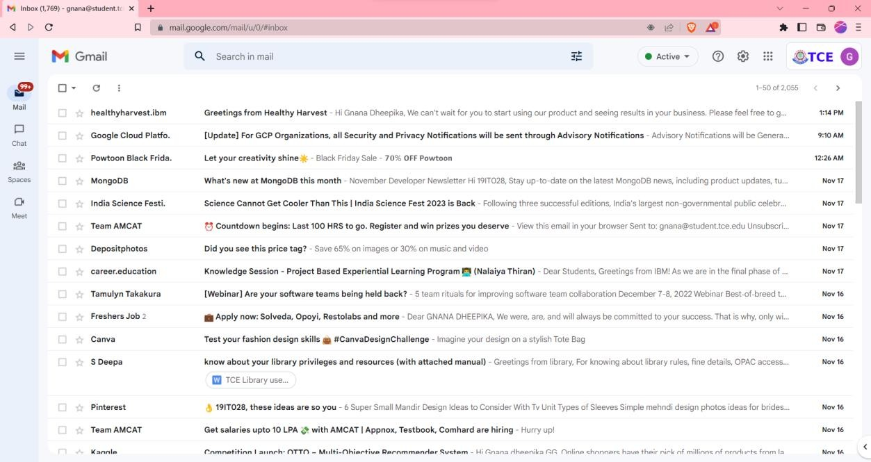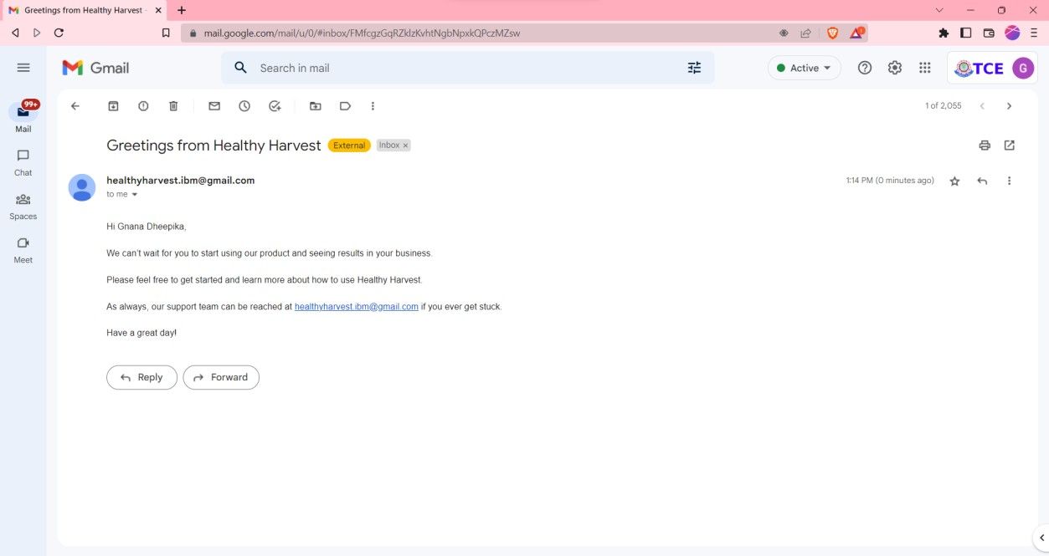

**Functional Requirement (Epic):** Registration

**User Story Number:** USN-4

**User Story / Task Story:** As a user, I can register for the application through Gmail

Points: 1

**Priority:** Medium

**Team Members:** Logeshavan R

Screenshots:

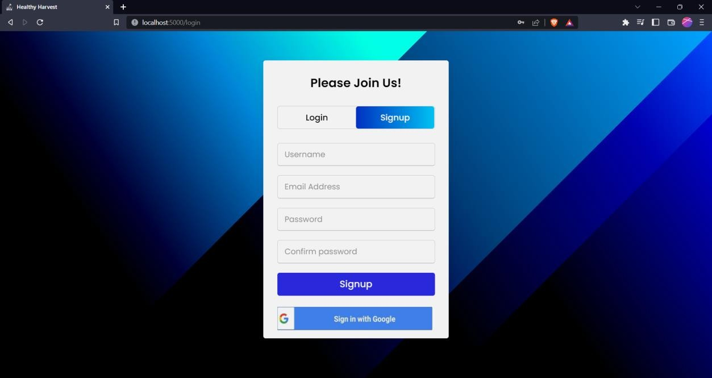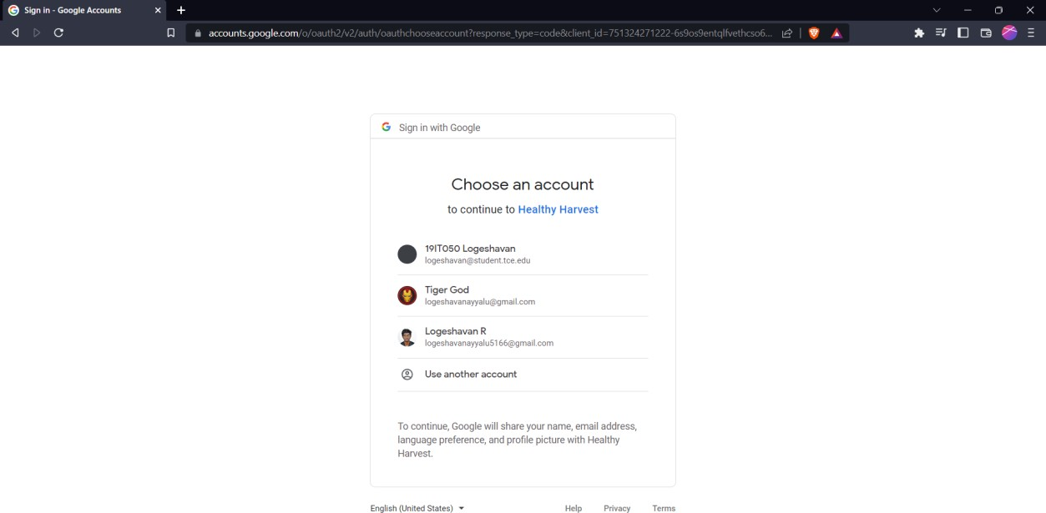

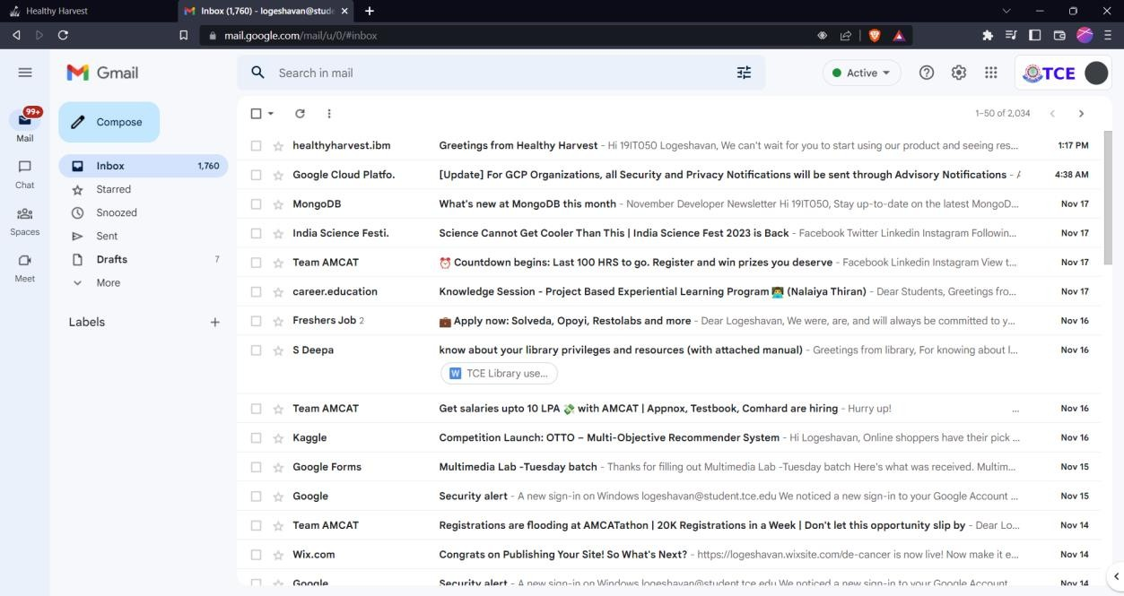

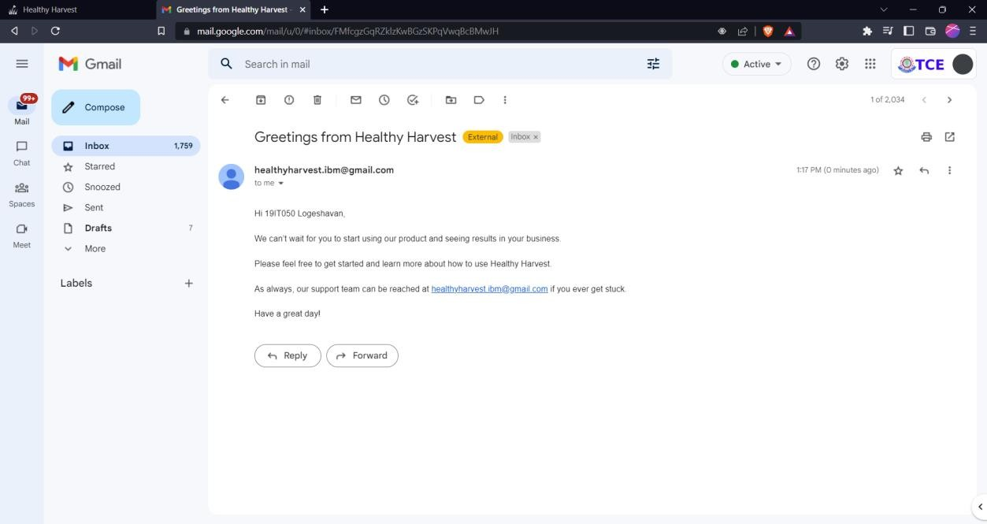

Functional Requirement (Epic): Login

**User Story Number:** USN-5

**User Story / Task Story:** As a user, I can log into the application by entering email & password

Points: 1

**Priority:** High

**Team Members:** Gnana Dheepika G G

Screenshots:

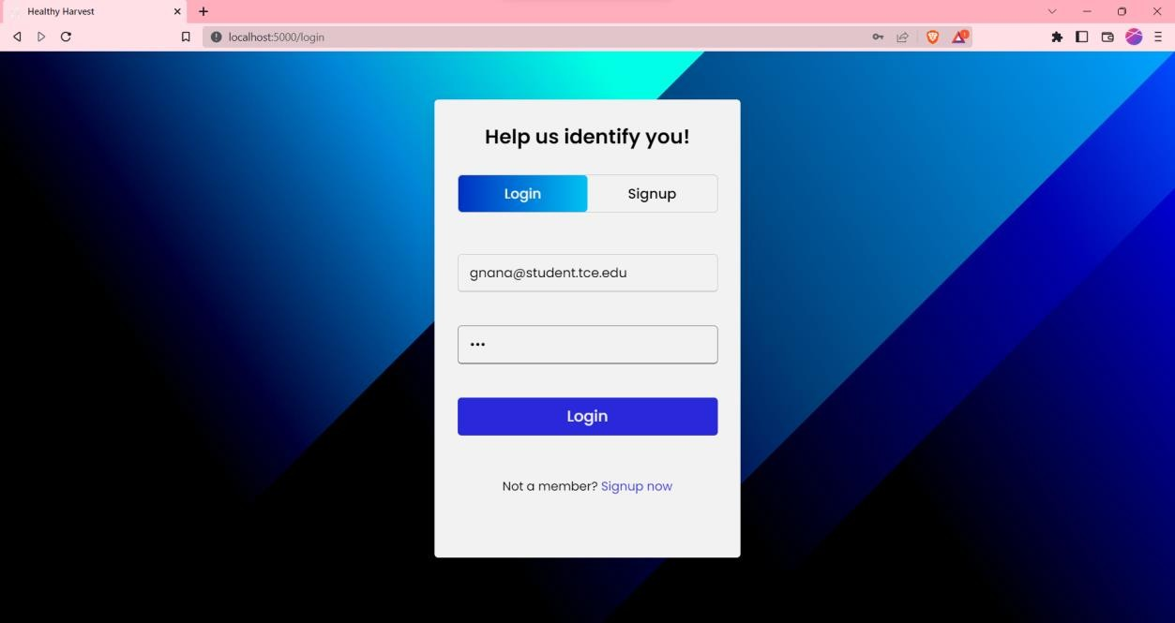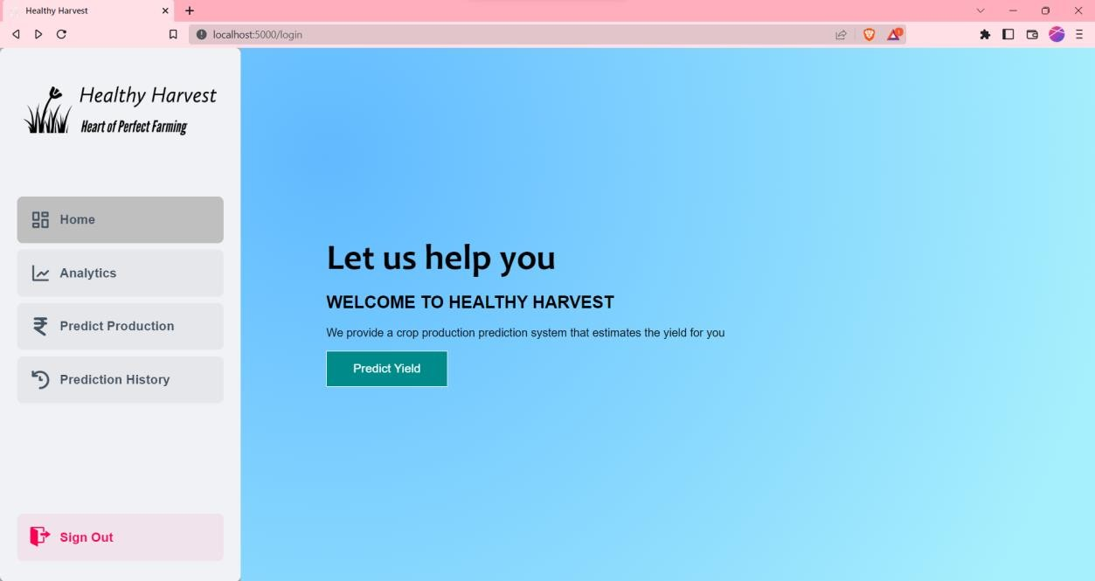

**Functional Requirement (Epic):** Dashboard

**User Story Number:** USN-6

**User Story / Task Story:** As a user, I can use the methods provided in the dashboard

Points: 2

**Priority:** Medium

**Team Members:** Roshika B

Screenshots:

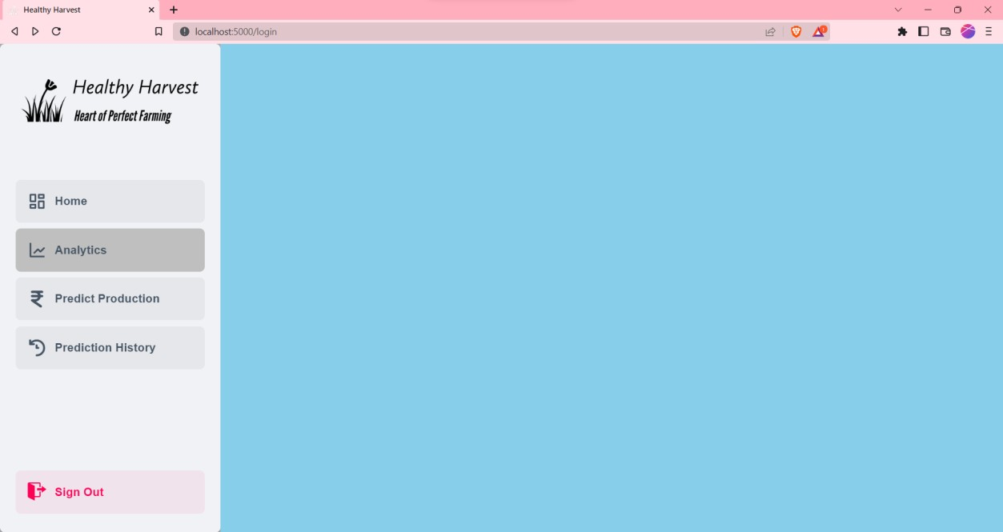

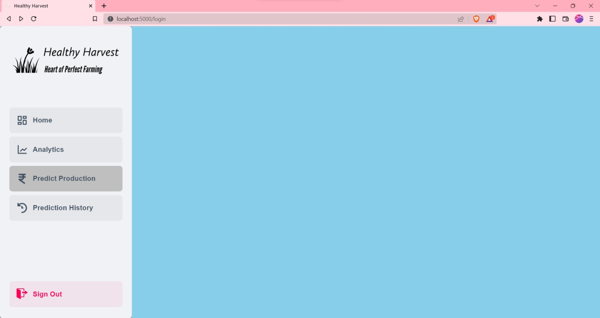

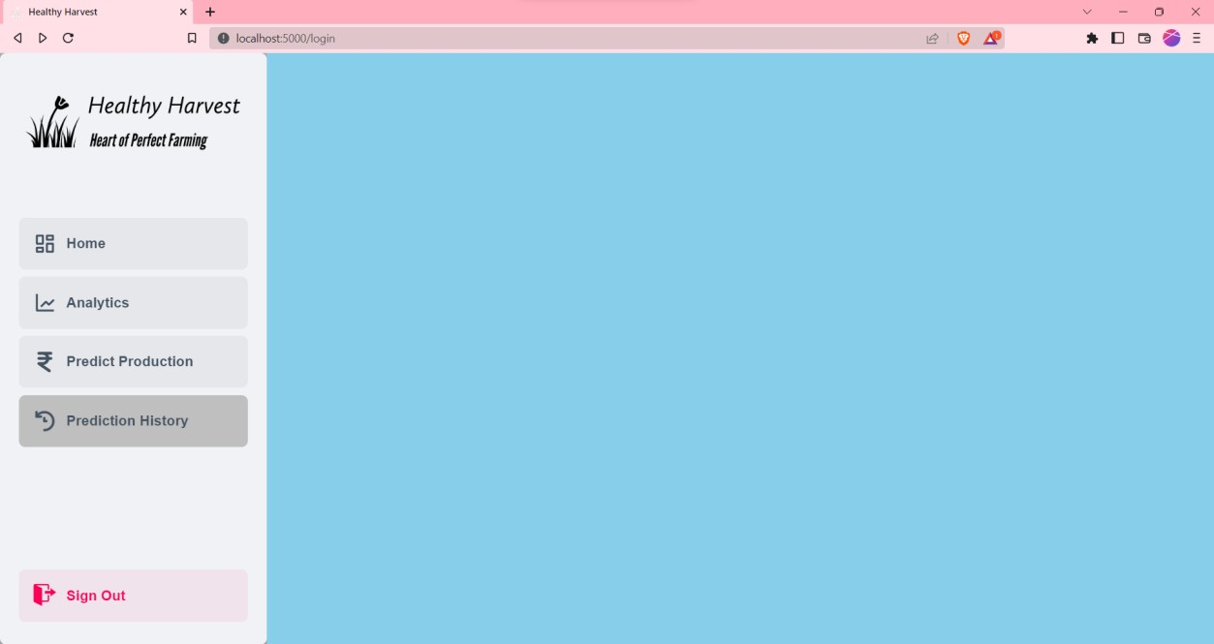

**Functional Requirement (Epic):** Accessing the resources

**User Story Number:** USN-9

**User Story / Task Story:** As a user, I can Identify my account with set of unique credentials

Points: 2

**Priority:** High

**Team Members:** Gnana Dheepika G G

Screenshots:

Accounts Database:

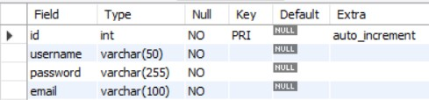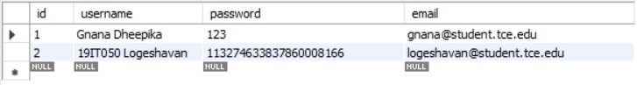

The user can be distinguished with email/id.